AL DERMATOLOGY PC
LYUBOV AVSHALUMOVA D.O. F.A.O.C.D.
80 BEEKMAN STREET NEW YORK, NY 10038
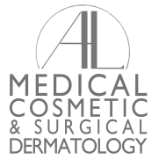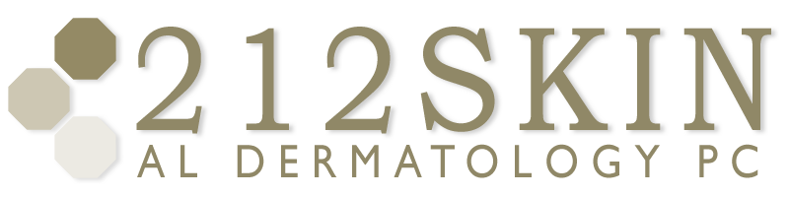
_____________________________________________________________________________________
P: (212) 729-SKIN (7546) | F: (212) 729-9395 | Email: contact@212skin.com | www.212SKIN.com
September 25, 2013
Dr.

Dear Dr. Cheung:
I would like to take this opportunity to introduce myself.
My name is Dr. Lyubov Avshalumova. I am a Board Certified Dermatologist who recently started a practice at 80 Beekman Street in Downtown Manhattan. I graduated from New York College of Osteopathic Medicine in 2006, completed my internship at Lutheran Medical Center in Brooklyn in 2007 and Dermatology residency at Suncoast Hospital /Largo Medical Center in Largo, Florida in 2010. Since moving back to New York, I have been practicing dermatology in Manhattan, Brooklyn and on Long Island. I serve as an instructor in Clinical Dermatology for Columbia University Medical center and as affiliate staff member at Lutheran Medical Center. My scope of practice includes General Adult and Pediatric Dermatology as well as Surgical and Cosmetic Dermatology.
I have enclosed my business cards and brochures which describe my practice and services. Professionalism, communication, and quality care are my priorities. If you have any questions or have a patient that needs a dermatologic consultation, please feel free to contact me at 212 729-SKIN (7546).
Thank you for your time and consideration.
I look forward to working with you as a team in providing quality medical care to our community.
Yours sincerely,

Lyubov Avshalumova, DO, FAOCD

